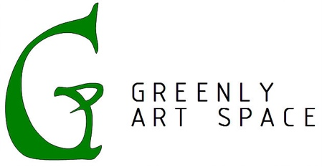
Press Release
For Immediate Release
Contact: Zachary Miller
Phone: (562) 883-0362
Email: barten06@gmail.com
Greenly Art Space Uses Grant to Help Local Artist
Release: Signal Hill, CA – July 8, 2019
Greenly Art Space is pleased to announce that they have received an “Artists in Communities” grant from the California Arts Council. This grant helps artists create work that is relevant to the communities in which they live.
Greenly Art Space will be using these funds to work with Juan Gomez. He is a CSU Fullerton graduate whose work has been shown at the CSUF Pollack Library, Torrance Art Museum, and at group exhibits in Greenly Art Space.
Funds from the grant will help set up an exhibit devoted to Gomez’s emerging career. Titled “Running in Place”, the exhibit will open on October 19th, 2019, and close on January 11th, 2020.
Director and curator, Kimberly Hocking, states, “I am excited to work with Juan on his first solo exhibition. Bringing my years of experience working with artists and curating art exhibits, I hope to guide Juan on his journey to showcase his textured and multilayered work. We are excited to be able to bring this exhibit to the public with the vital grant from the California Arts Council.”
Gomez states, “Initially when I started this body of work, the ideas […] present at the time, were reactions to social, political, and economic facets that have given other artists like myself a need to speak up creatively. The further I go along though, the more I realize that it’s not only things on the outside that I am reacting to, it’s things on the inside as well; it’s thoughts and memories, it’s past and present.”
Gomez will receive monthly two-hour mentoring sessions beginning in July 2019. In these, he will work with Hocking to learn more about gallery curation. Gomez will also post about his creative process on Greenly Art Space’s blog.
Greenly Art Space believes that this is an excellent opportunity to help nourish the growth of a vital artist and expose patrons to the vibrancy of art in Southern California.
Greenly Art Space is a nonprofit art gallery located in Signal Hill, CA. Since Greenly’s inception in 2010, it has focused provided a space for creativity, contemplation, and community.
This activity is supported in part by the California Arts Council, a state agency. Learn more at www.arts.ca.gov.
Any findings, opinions, or conclusions contained herein are not necessarily those of the California Arts Council.

