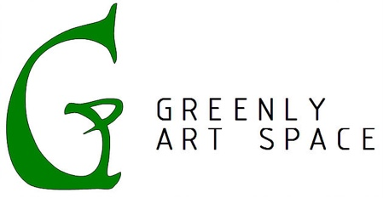
Press Release
For Immediate Release
Contact: Kimberly Hocking
Phone: (562) 533-4020
Email: kimhocking@aol.com
or
Contact: Lara Duke
Phone: (310) 529-9599
Email: studio@skondovitch.com

Release: SIGNAL HILL, CA-February 10, 2023
On March 11th, 2023, from 4-7pm Greenly Art Space will host the opening reception of “Skondovitch: A Legacy,” which will feature selected work by the late Abstract Expressionist Alfred Skondovitch. Skondovitch lived and painted in New York in the 1940s and 1950s. He exhibited with other artists of that era such as Willem de Kooning, Richard Diebenkorn, and Robert De Niro, Sr. Ultimately he left New York for California and continued on to Alaska, where he lived and painted for over fifty years.
The show will include a mix of paintings from large oil and acrylic abstract works on canvas from the 1950s, to selected Holocaust pieces documenting his experience as a witness during Bergen Belsen concentration camp liberation, to his figure studies and landscapes.

In many ways Skondovitch's life story was as rich as his art. He came to New York from his home country of England in 1947, at the recommendation of an art teacher in London, who was the sister-in-law to artist Franz Kline. In New York he studied with the German Expressionist painter and teacher Hans Hofmann, and frequented the Cedar Bar, the haunt of avant garde artists of that time. Later in life Skondovitch, an avid raconteur, recounted many of these and other stories. Life events included evacuation to the countryside as a child during the war, assisting with stage sets and costumes for Oscar Kokoschka, and fighting forest fires in Alaska with a group of Claremont College art students.

Of his work, Skondovitch stated: "I produce my art because I have to, the way people breathe. I have worked since childhood. In order to express myself I must get the ideas in my head on paper or canvas. I feel you are influenced by others in your art and you also influence others—it is this cauldron that makes the artist. My roots are in the Abstract Expressionist movement of the 1940s and 1950s; in the 1950s I worked and studied in New York where I had the privilege of personal friendships with many artists of this movement. I have worked on paper, mutating conventional media by mixing watercolors, oil pastels and acrylics together, bringing a monoprint to underlie a painting. This is one way that I make my art. Others are oil on canvas, basic acrylic and watercolors on paper."

Skondovitch's family is excited at the opportunity to share some of his work with art lovers outside of Alaska. "My dad's work has a distinct following in Alaska, but to expose it to others has been a long-time dream for us. He wanted to leave a legacy, and us getting it into the public eye we hope will help to perpetuate his legacy. All of his art is impactful, but of special importance to us is getting his Holocaust works seen. These are a first person account of the horrors intolerance can produce and are especially relevant in today's world. Their power really must be experienced in person," said daughter, Lara Duke.
Greenly Art Space’s Curators, Kimberly and David Hocking traveled to Alaska to select works specifically for this exhibit. Kimberly states, “Spending time in Alfred Skondovitch’s studio brought the joy of discovery and the deep desire to share his moving artwork with a wider audience. In working to curate the pieces for this show, we have endeavored to highlight a depth and breadth of the legacy that he has left for us all.”
"Skondovitch: A Legacy" will have its opening reception March 11th from 4pm – 7pm and will run through May 12th and can be seen during regular gallery hours, Monday, Wednesday, Friday between 11am-2pm or by appointment (562)533-4020. Greenly Art Space is a nonprofit art gallery located in Signal Hill, CA. Since Greenly’s inception in 2010, it has focused on providing a space for creativity, contemplation, and community.

